

**HOMEHIVE**

**A Group Project Submitted for Undergraduate DBMS Lab**

**(BCA 481) 2022 -2023**

**By**

AHANYA MARIAM POKKAMTHANAM (2241107)

ANTONY CHANDY DOUGLAS (2241117)

RUCHIT DHANUKA (2241150)

**Bachelor of Computer Science Under the supervision of**

# **Dr. KIRUBANAND V B**

## Project report submitted in partial fulfilment of the requirements of IV semester BCA, CHRIST (Deemed To Be University)

**April - 2023**



# CERTIFICATE

This is to certify that the report titled **E-commerce** is a bona fide  record of work done by **Ahanya Mariam Pokkamthanam (2241107), Antony Chandy Douglas (2241117)  and Ruchit Dhanuka (2241150)** of CHRIST (Deemed to be  University), Bangalore, in partial fulfilment of the requirements of IV  Semester BCA during the year 2023-24.

**Head of the Department Project Guide**

**____________________ ____________________**

**Valued-by:**

## ACKNOWLEDGEMENT

First of all, we thank God almighty for his immense grace and blessings showered on us at every stage of this work. We are grateful to our respectable Head, Department of Computer Science, CHRIST (Deemed to be University), **Dr Ashok Immanuel V**, for providing the opportunity to take up this project as part of my curriculum.

We also pay our gratitude to the Coordinator, Department of Computer Science, CHRIST (Deemed to be University) **Dr Beaulah Soundarabai P** for their support throughout.

We are grateful to our guide, Associate Professor, Department of Computer Science, CHRIST (Deemed to be University), **Dr Kirubanand V B**, whose insightful leadership and knowledge benefited us to complete this project successfully. Thank you so much for your continuous support and presence whenever needed.

We would also like to thank our Alumni evaluator **Mr Abdul Kareem MA,** whose knowledge and guidance benefited us in making the changes as per the industry requirement. Thank you so much for your support and presence whenever needed.

We express our sincere thanks to all faculty members and staff of the Department of Computer Science, CHRIST (Deemed to be University), for their valuable suggestions during the course of this project. Their critical suggestions helped us to improve the project work.

Last but not the least, we would like to thank everyone who is involved in the project directly or indirectly.

**CONTENTS**

1. **Introduction 6** 
   1. **The Project Description 6**
   2. **Existing System 6**
   3. **Objectives 8**
   4. **Purpose, Scope and Applicability 8** 
      1. **Purpose 8**
      2. **Scope 8**
      3. **Applicability 8**
   5. **Overview of the Project 9**
2. **System Analysis and Requirements 10** 
   1. **Problem Definition 10**
   2. **Requirement Specification 10** 
      1. **Functional Requirements 10**
      2. **Technical Requirements 10**
   3. **System Requirements 12** 
      1. **Software Requirements 12**
      2. **Hardware Requirements 12**
      3. **Network Requirements 12**
   4. **Conceptual Models 13** 
      1. **Data Flow Diagram 13**
      2. **ER Diagram & Class Diagram 15**
   5. **Planning and Scheduling 16** 
      1. **Gantt Chart 16**
      2. **PERT Chart 17**
   6. **Proposed Tools 16**
3. **Module Descriptions 19** 
   1. **Bank 19**
   2. **Branch 19**
   3. **Admin 19**
   4. **Users 20**
   5. **Existing Users 20**
4. **Proposed Process Logic of Modules 24**
5. **Testing 25** 
   1. **Testing Strategies 25**
   2. **Test Cases and the Reports 26**
6. **Tables 28**
7. **UI and Implementation 32**
8. **Future Enhancements 43**
9. **Conclusion 44**
10. **Appendix 45**

## 1. INTRODUCTION

### 1.1 PROJECT DESCRIPTION

The world is becoming more Tech savvy day by day. New inventions and discoveries are constantly happening every moment. However yet, not all of us have adopted all these developments. In the Banking sector, we find that all Banks have Online banking systems but these apps are only for existing users.

Not all banks have inculcated the feature of creating a zero-balance account for the new users. That is why our project Bank is Hand, helps people to create their accounts in the bank in the online mode. The main objective of this project is to make new account creation more feasible for people in this bustling era. This platform will connect more people to different banks even if they are far away.

### 1.2 EXISTING SYSTEMS

The idea of the online banking is well known now especially after the covid period. The existing modules of our domain area focus on the banking works in an online mode. It gives emphasis to the existing customers.

The following are a few projects that the team has worked on improving (along with the hyperlink).

#### 1.2.1 Banking Management System [(studocu)](https://www.studocu.com/row/document/university-of-colombo/software-engineering/banking-management-system/16596825)

The main purpose of this project is to simplify the tedious task of banking by providing this service in a user-friendly environment.

This software allows the users to apply for new account and to update the previous account.

#### 1.2.2 Bank Account Management System [(ResearchGate)](https://www.researchgate.net/publication/301293322_Bank_Account_Management_System)

The main aim of this project is to develop software for Bank Account Management System. This project has been developed to carry out the processes easily and quickly, which is not possible with the manuals systems, which are overcome by this software. This project is developed using PHP, HTML language and MYSQL use for database connection.

#### 1.2.3 Bank Management System [(academia)](https://www.academia.edu/24813368/BANKING_MANAGEMENT_SYSTEM)

The main objective of this project was to provide various types of customer service options for the users thus the main objective of this to find out about customer facilities.

#### 1.2.4 Banking Management System [(lovelycoding)](https://www.lovelycoding.org/banking-management-system/)

The main aim of this project is to manage bank branches throughout the system they used this module which kept the manageability of the branches and provide a unique identity to every branch.

They also aimed that the branch module will also help banks find out about their performance at a different location so they evaluate on this improve the customer service quality

#### 1.2.5 Bank Management System [(muengineers)](http://www.muengineers.in/computer-project-list/visual-basic-projects-list/bank-management-system)

To develop a software for solving financial applications of a customer in banking environment in order to nurture the needs of an end banking user by providing various ways to perform banking tasks. Also to enable the user and workspace to have additional functionalities which are not provided under a conventional banking software.

### 1.3 OBJECTIVES

Our objective is to develop a website under which n number of banks can register and customers(new) can directly create an account with zero balance online without going to bank

### 1.4 PURPOSE, SCOPE AND APPLICABILITY

**1.4.1. Purpose**

All the existing projects have worked upon the online banking system for only existing customers and not new ones. This website will solely help to create accounts of new users without any difficulty. Moreover, one can visit multiple banks via one webpage.

**1.4.2. Scope**

We live in a fast era of technology where no one has spare time to stand in a long queue to open an account this website will be a boon to them.

**1.4.3. Applicability**

* The project is applicable for all banks to gain more customers and spread pan-India is the banks are regional. Customers can also open zero-balance account through a few clicks in savings or current mode.
* Big companies who are continuously recruiting employees can easily create their accounts with the employee’s choice of bank
* Physically challenged people and those who are old aged don’t have to suffer any physical strains that are involved in creating a bank account at the bank itself such as rush, travel requirements etc.

### 1.5. OVERVIEW OF THE PROJECT

This project is about creating a zero-balance bank account in the banks those have registered in the website through online mode in a hassle-free manner. The bank account creation system - Bank in Hand ensures that we make better connectivity between banks and the people in a fast and easy way. It will make the bank more approachable to people and will benefit both customers as well as the bank organisations.

## 2.SYSTEM ANALYSIS AND REQUIREMENTS

### 2.1 PROBLEM DEFINITION

In the Banking sector, we find that all Banks have Online banking systems but these apps are only for existing users. Not all banks have inculcated the feature of creating a zero-balance account for the new users. Our project Bank is Hand, helps people to create their accounts in the bank in the online mode. The main objective of this project is to make new account creation more feasible for people in this bustling era. This platform will connect more people to different banks even if they are far away.

### 2.2. REQUIREMENT SPECIFICATION

**2.2.1. Functional Requirements**

* The software facilitates selection of various banks to access from a common portal
* There is an option which provides for new user account creation
* Existing customers can create new accounts in different banks according to their desire
* Users can view their various account details and update certain restricted details
* Users can directly close their accounts in these banks through the portal

**2.2.2. TECHNICAL REQUIREMENTS**

* Data privacy
  + Confidential data such as account details are secure within the database
  + Bank In Hand ensures that personal data is kept secure and not shared with any outside users without authentication

* Performance
  + The user must have a secure internet connection through which they can access the website
  + The performance of the website depends on the system specifications of the user and the browser they are accessing it with

* Data Security
  + The information stored by the security is stored in a secure manner such as account passwords

* Data Storage
  + The data is securely stored in a database
  + The database can only be accessed by authenticated admins of the software

* Reliability
  + The website is well designed with attractive colour palettes for good user interface
  + It is optimized for easy access and working of users so that anyone can easily do their required banking operations

### 2.3 SYSTEM REQUIREMENT

#### 2.3.1 HARDWARE REQUIREMENTS

**OS: Windows 10 or above**

**Processor: Core 2 Duo**

**Memory: 4 GB RAM**

**Storage: 1 GB available space**

#### 2.3.2 SOFTWARE REQUIREMENTS

**Operating System: Windows 7 or later**

**Front End: PHP / HTML / JavaScript**

**Back End: MySQL**

**Software Required: XAMMP/PHPMyAdmin**

#### 2.3.3 NETWORK REQUIREMENTS

**Network: Google Chrome / Mozilla or equivalent WIFI: Internet Required.**

### 2.4 CONCEPTUAL MODEL

**2.4.1 DATA FLOW DIAGRAM (DFD)**

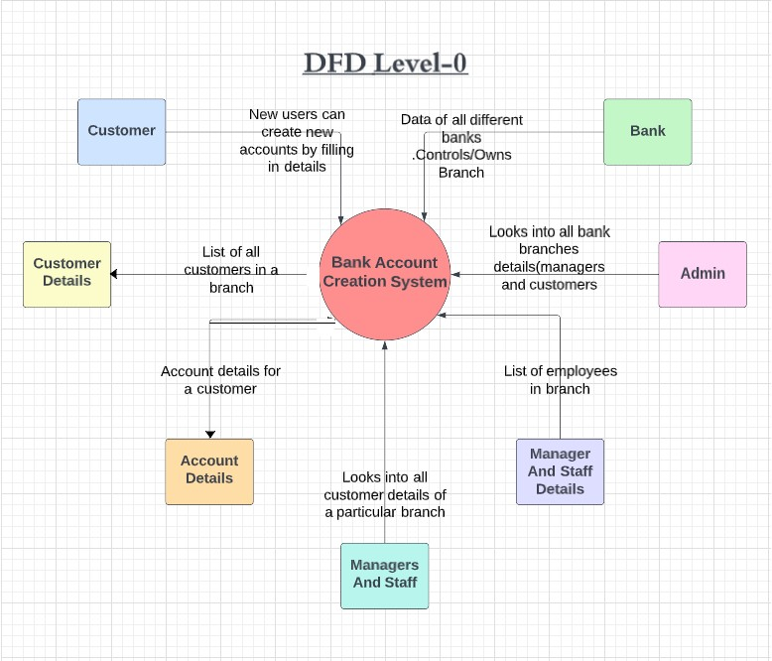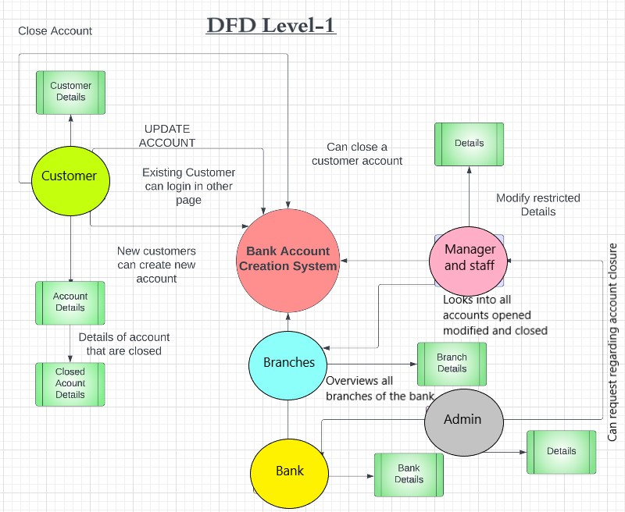

**2.4.2 ER DIAGRAM AND CLASS DIAGRAM**

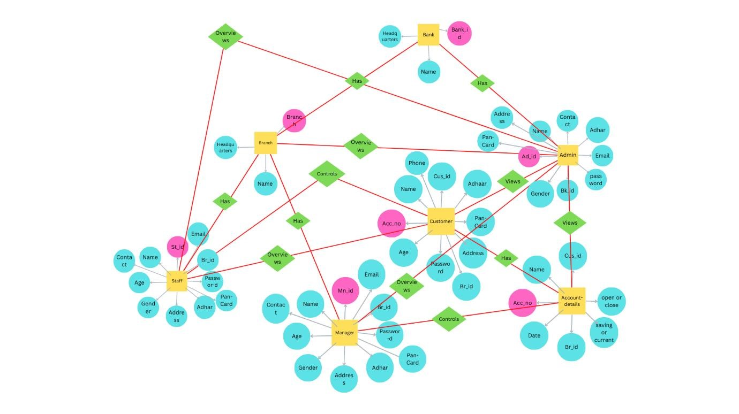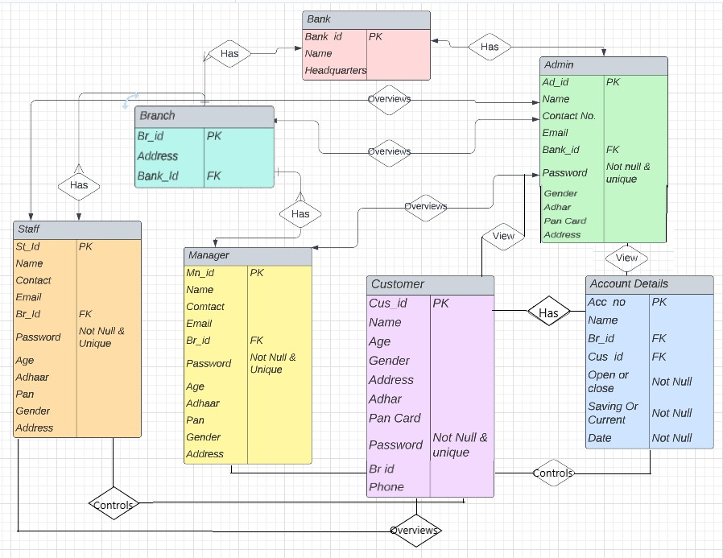

### 2.5 PROJECT PLANNING

**2.**

**5**

**.1**

**GANTT CHART**

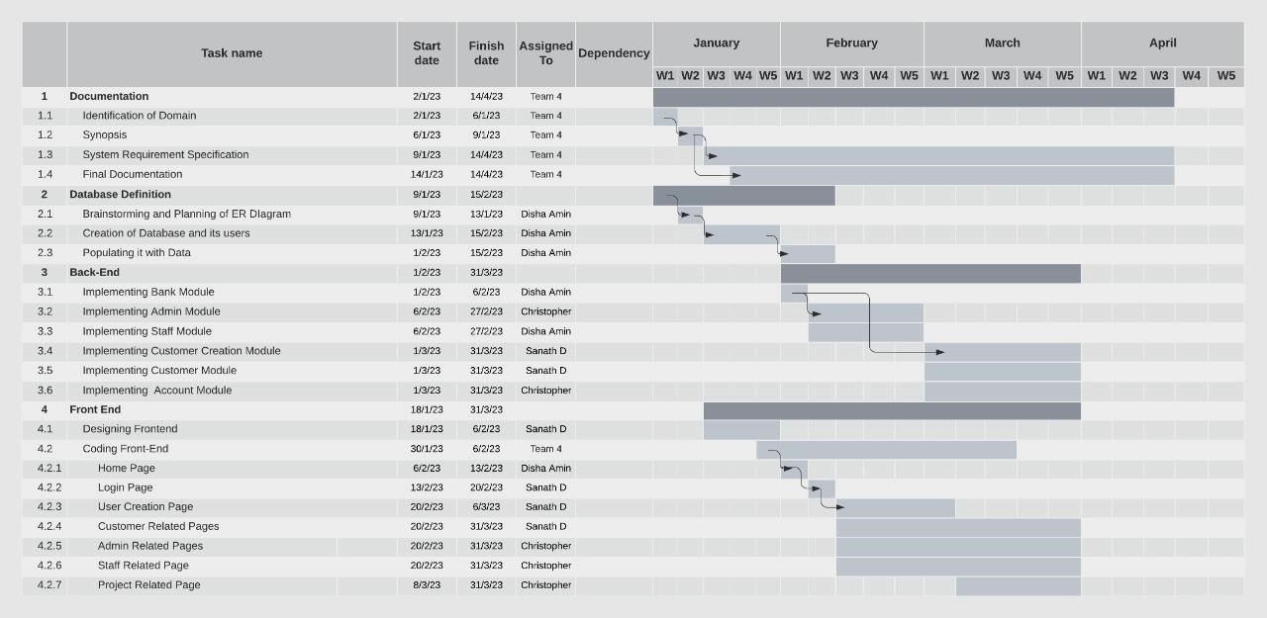

**2.5.2 PERT CHART**

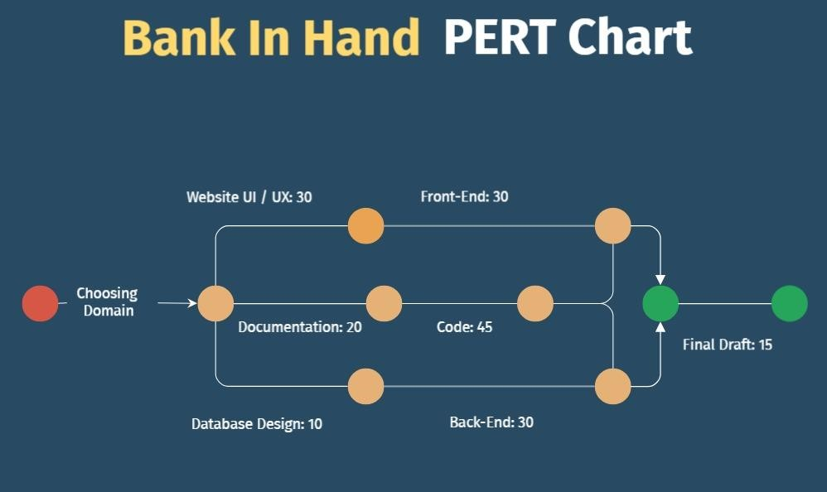

### 2.6. PROPOSED TOOLS AND PLATFORMS

**2.6.1. Windows 10**

Microsoft Windows 10 is a personal computer operating system developed and released by Microsoft. All the files containing code and database will be created in the Windows 10 operating system.

**2.6.2. Google Chrome**

Google Chrome is a cross platform web browser developed and maintained by Google. All the html and php files will be opening using Google Chrome for viewing their functionality and working.

**2.6.3. HTML**

HTML stands for Hypertext Mark-up Language which is the standard mark-up language for documents designed to be displayed in a web browser. The basic web pages design will be implemented using HTML.

**2.6.4. CSS**

CSS or Cascading Style Sheets is a style sheet language used for describing the presentation of a document written in a mark-up language such as HTML. It will be used for adding more design and improving the look and feel of the website.

**2.6.5. JavaScript**

JavaScript, often abbreviated as JS, is a programming language that conforms to the ECMAScript specification. It is high-level, often just-in-time compiled, and multi-paradigm. It will be used to make the website responsive and dynamic.

**2.6.6. PHP**

PHP is a general-purpose scripting language especially suited for web development. It will be used to write the codes for the server side and connect to the database.

**2.6.7. MySQL**

MySQL is an open-source relational database management system. The data will be stored in a database while following maximum normal forms.

**2.6.8. VISUAL STUDIO CODE**

Visual Studio Code is a source-code editor that can be used with a variety of programming languages, including C#, Java, JavaScript, Go, Node.js, Python, C++, C, Rust and Fortran. It is based on the Electron framework, which is used to develop Node.js web applications that run on the Blink layout engine. Visual Studio Code employs the same editor component (codenamed "Monaco") used in Azure DevOps (formerly called Visual Studio Online and Visual Studio Team Services).

**3.Module Descriptions**

### 3.1. BANK

Bank consists of

* Bank ID of bank
* Name of the Bank
* Headquarters of the bank

### 3.2. BRANCH

Branch consists of

* Branch ID of the particular branch of the bank
* Address
* Manager ID of the manager of the bank
* Bank ID of the bank

### 3.3. ADMIN

Admin consists of

* Admin ID
* Name
* Contact No.
* Email
* Bank ID
* Password
* Gender
* Address
* Aadhaar Card
* Pan Card

They can overview all the branches and its working. They can request the branch manager to close any account on necessary situations

### 3.4. CUSTOMER

Customer consists of

* Customer ID
* Name of the customer
* Age
* Gender
* Address
* Aadhaar
* Pan
* Password
* Br ID
* Phone

This module consists of customers in the login page where he/she has to login via user_ ID and password.

### 3.5. NEW CUSTOMER

New customer Login page will comprise of the details to be filled in after which they will receive their user_ ID and password.

### 3.6. MANAGER

Manager consists of

* Manager ID
* Name
* Contact
* Email
* Brach ID
* Password
* Age
* Aadhaar
* Pan
* Gender
* Address

They overview the account details, customer details of the branch and new account created or account closed can be viewed by them.

They can close the account of the customer under necessary condition.

### 3.7. STAFF

Staff consists of

* Staff ID
* Name
* Contact
* Email
* Brach ID
* Password
* Age
* Aadhaar
* Pan
* Gender
* Address

They overview the account details, customer details of the branch and new account created or account closed can be viewed by them.

They can’t close the account of the customer under necessary condition.

### 3.8. ACCOUNT DETAILS

Account Details consists of

* Account Number
* Name
* Branch ID
* User ID
* Open or close account
* Savings or current account
* Date of Creation

## 4. PROPOSED PROCESS LOGIC OF MODULES

Bank account creation is also a kind of a person's existential proof. Moreover, we want people to get to know about the different banks in our country. So, if they wish, they can easily create an account in the bank they want. It will also be helpful for big companies to create accounts for all their new Employees without any hassle. The bank account creation system - Bank in Hand ensures that we make better connectivity between banks and the people in a fast and easy way.

* First customer opens the website
* Clicks on desired bank and chooses the branch
* It goes to a page where they select from which category they are and process
* Staffs will go to the login page and enter via user id & password
* Then move on to their portal
* Login page where they can overview the work going on with customer accounts
* Users can login to their page via user id and password after that they can view their account details and update restricted columns and can close their accounts
* New users can login via filling in their details and automatically bank branch will give their user id and password log in and they can create their account
* Managers can close customer accounts when admin asks him to do so in some typical situations.
* A customer can create multiple accounts in same or different branches and banks
* These points make up the process logic of the project

## 5. TESTING

### 5.1 TESTING STRATEGIES

A strategy for software testing integrates software test cases into a series of well-planned steps that result in a successful construction of software. Software testing is a broader topic for what is referred to as verification and validation. Verification refers to the set of activities that ensure that the software that has been built is traceable to customer’s requirements. The steps involved in testing are-

#### 1. Unit testing

Unit testing means testing each unit of design separately. Here in this project, we tested each unit of design separately and verify that there were no errors. For this testing each design is run individually After executing each page if there any error occurs correction mechanism is done instantly.

#### 2. Integration testing

In our project we combine many units of module to form a sub system. These sub systems are then tested. This is done to see whether the modules can be integrated properly. Based on integration testing some necessary changes were made to the design.

#### 3. System testing

System testing is done to ensure the entire software performs its function as intended. In our project all the tested subsystems were integrated and tested for all the possible ranges of coupling variables, based on the testing errors were rectified for pleasant working experience.

#### 4. Acceptance testing

The goal of acceptance testing is to see if the software meets all the requirements as needed. The testing was performed by data of all the users of the system. It was found that the software meets all the requirements of the host, tenant, administrator and service providers as needed.

##### 5.2 TEST CASES AND REPORTS

**Login Module:**

|  |  |  |  |
| --- | --- | --- | --- |
| **1.1** | **Input:** Valid credentials and the right bank/branch | **Output:** Successfully logged in | The user is successfully logged into his account and redirected to their dashboard. |
| **1.2** | **Input:** Invalid credentials and the right bank/branch | **Output:** Enter the right credentials, Incorrect  Username and password | The user is sent a prompt to recheck their details and enter the right credentials. |

**User Registration Module:**

|  |  |  |  |
| --- | --- | --- | --- |
| **2.1** | **Input:** Valid details entered following all the validations | **Output:**  User_successfully registered | The user is successfully registered into the database and redirected to the login page. |
|  |  |  |  |
| **2.2** | **Input:** Valid details entered, but empty fields | **Output:** Enter all the details | The user is prompted to please  fill in all their details. |
| **2.3** | **Input:** Data entered fails validations or incorrect format | **Output:** Please enter valid details | The user is prompted to recheck and enter the right data as per the requirement. |

## 6. TABLES

### Staff

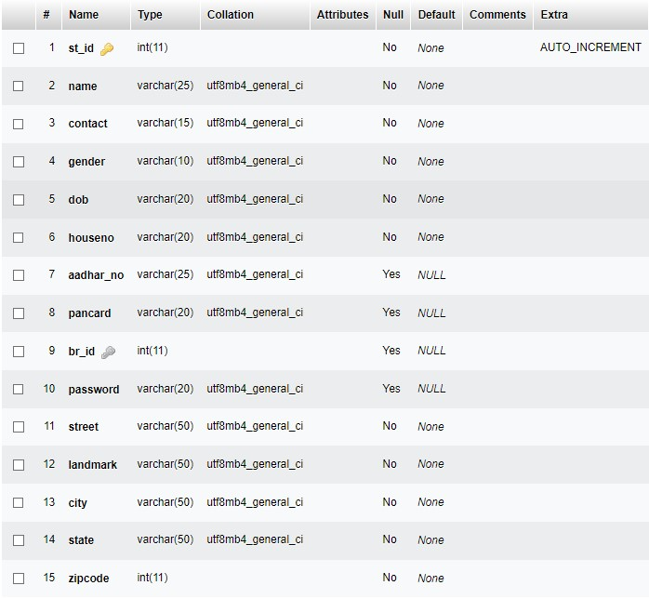

### Bank

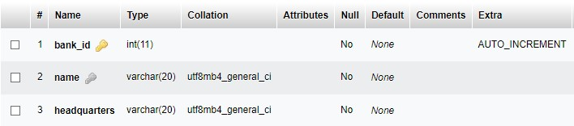

### Manager

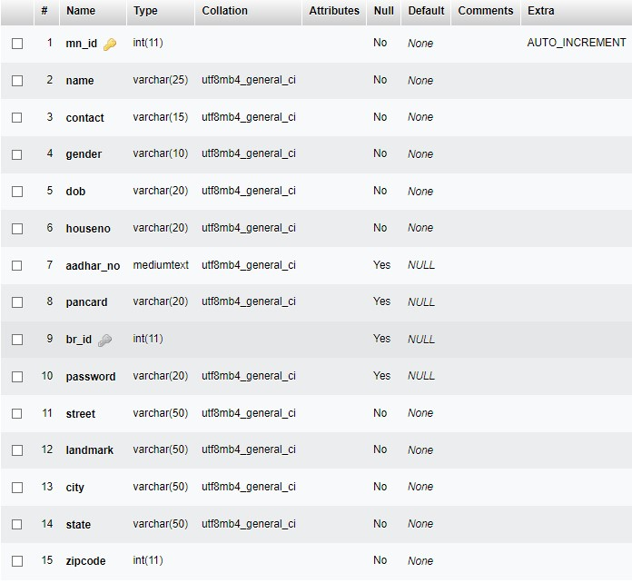

### Branch

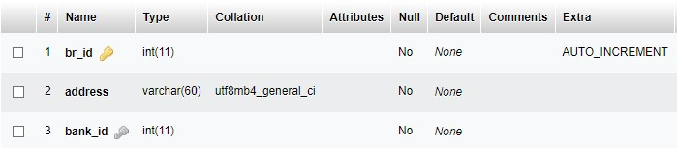

### Admin

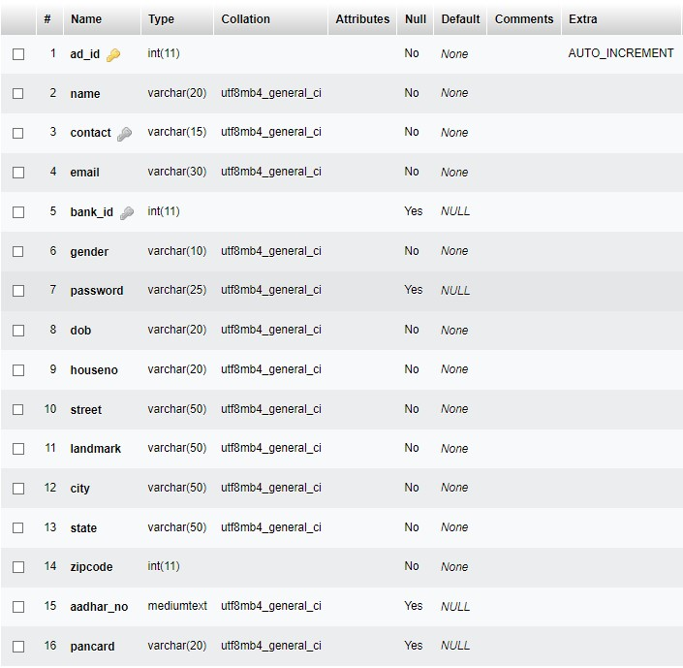

### Customer

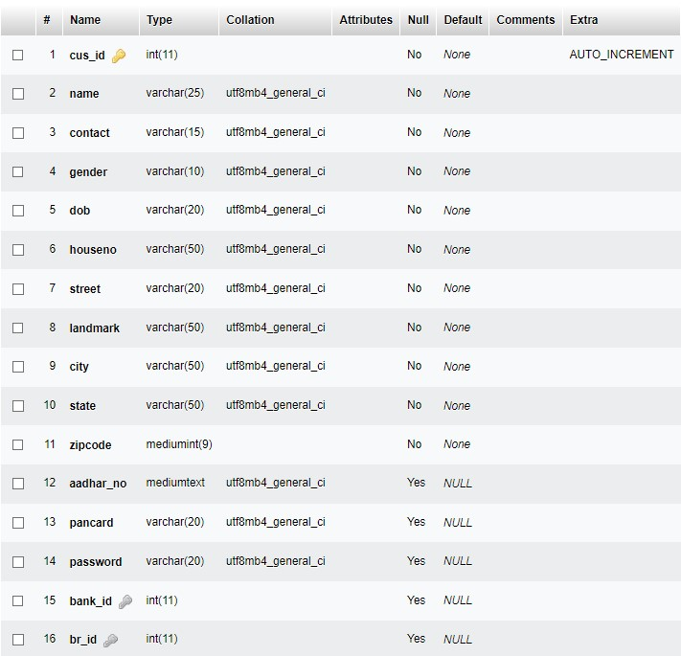

### Account

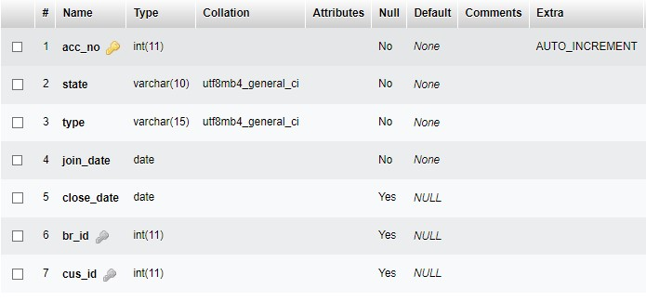

### 7. Implementation & UI

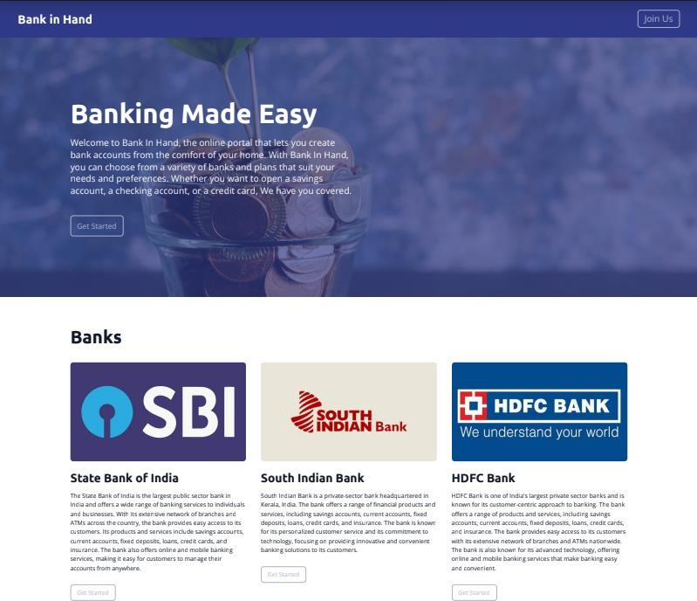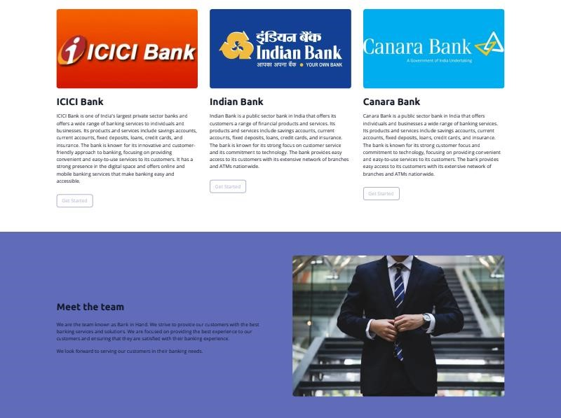

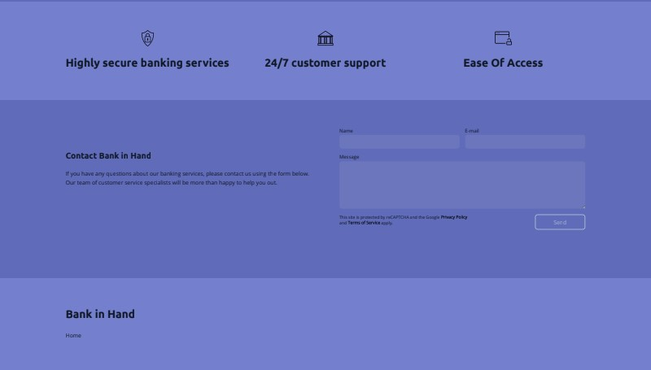

Implementation:

<!DOCTYPE html>

<html>

<head>

<meta charSet="utf-8" />

<meta name="viewport" content="width=device-width" />

<meta name="theme-color" content="#2E3A87" />

<link rel="icon" href="/favicon.ico" />

<title>Home Page</title> <meta name="description"

content="Bank in Hand, located in Bangalore Division, KA, is a fullservice banking business offering convenient services such as checking and savings accounts, loans, investments, and more. With our experienced team of professionals, we are committed to providing the best customer service and financial solutions." />

<meta name="keywords" content="keyword" />

<meta property="og:title" content="Home Page" />

<meta property="og:type" content="website" />

<meta property="og:description"

content="Bank in Hand, located in Bangalore Division, KA, is a fullservice banking business offering convenient services such as checking and savings accounts, loans, investments, and more. With our experienced team of professionals, we are committed to providing the best customer service and financial solutions." />

<link rel="preconnect" href=["https://fonts.googleapis.com"](https://fonts.googleapis.com/) />

<link rel="preconnect" href=["https://fonts.gstatic.com"](https://fonts.gstatic.com/) />

<link rel="stylesheet"

data-

href=["https://fonts.googleapis.com/css2?family=Ubuntu:wght@700&amp;family=Open](https://fonts.googleapis.com/css2?family=Ubuntu:wght@700&amp;family=Open+Sans:wght@400&amp;display=swap)

[+Sans:wght@400&amp;display=swap"](https://fonts.googleapis.com/css2?family=Ubuntu:wght@700&amp;family=Open+Sans:wght@400&amp;display=swap) data-optimized-fonts="true" />

<meta name="robots" content="noindex,nofollow" />

<style>

#nprogress .bar { background: #A9B4D3; box-shadow: 0 0 10px #A9B4D3;

}

</style>

<meta name="next-head-count" content="15" />

<link rel="preload" href="/_next/static/css/c678f8121a178477.css" as="style" />

<link rel="stylesheet" href="/_next/static/css/c678f8121a178477.css" datan-g="" />

<link rel="preload" href="/_next/static/css/30fd6dae99bf48e4.css" as="style" />

<link rel="stylesheet" href="/_next/static/css/30fd6dae99bf48e4.css" /><noscript data-n-css=""></noscript>

<script defer="" nomodule="" src="/_next/static/chunks/polyfillsc67a75d1b6f99dc8.js"></script>

<script defer="" src="/_next/static/chunks/664ac374a67af56732d.js"></script>

<script defer="" src="/_next/static/chunks/644e19b240598ae46f9.js"></script>

<script defer="" src="/_next/static/chunks/693c54d652e4eccb784.js"></script>

<script defer="" src="/_next/static/chunks/732.bec75d7cfa3415a5.js"></script>

<script defer=""

src="/_next/static/chunks/94.f00e1c53f76c128c.js"></script>

<script defer=""

src="/_next/static/chunks/175.de70ad08039feb9e.js"></script>

<script defer=""

src="/_next/static/chunks/925.c4bb35a50b0c1684.js"></script>

<script defer="" src="/_next/static/chunks/675-

1918b3cbce167ef3.js"></script>

<script defer=""

src="/_next/static/chunks/617.25ae01d1b11f9f5e.js"></script>

<script defer=""

src="/_next/static/chunks/383.731ba464b9b978fe.js"></script>

<script defer="" src="/_next/static/chunks/764f725e56f3f3798b5.js"></script>

<script defer="" src="/_next/static/chunks/674-

87d21fc98e9feabc.js"></script>

<script defer=""

src="/_next/static/chunks/77.bfdf04ef74f2607e.js"></script>

<script defer=""

src="/_next/static/chunks/165.5fc46622ab1ba1b8.js"></script>

<script src="/_next/static/chunks/webpack-91acce7e3b3c90b1.js" defer=""></script>

<script src="/_next/static/chunks/framework-8a37bd1e87a81516.js" defer=""></script>

<script src="/_next/static/chunks/main-ccefb599ad987b87.js" defer=""></script>

<script src="/_next/static/chunks/pages/_app-de0b152305ff5e07.js" defer=""></script>

<script src="/_next/static/chunks/c9184924-375a28b79120852d.js" defer=""></script>

<script src="/_next/static/chunks/228771e0-4f25607fabbf3101.js" defer=""></script>

<script src="/_next/static/chunks/65291039-c6f0e50e59aa756d.js" defer=""></script>

<script src="/_next/static/chunks/1b8dab7b-99ffffda4fe4c03e.js" defer=""></script>

<script src="/_next/static/chunks/561-9ce6a7286ef4ef3b.js" defer=""></script>

<script src="/_next/static/chunks/692-942df7d7594c8cc7.js" defer=""></script>

<script src="/_next/static/chunks/pages/%5B%5B...slug%5D%5Dc2a58b9f0c8d13e9.js" defer=""></script>

<script src="/_next/static/8JwBqYSgarN-HNRKJ3CcC/_buildManifest.js" defer=""></script>

<script src="/_next/static/8JwBqYSgarN-HNRKJ3CcC/_ssgManifest.js" defer=""></script> <link rel="stylesheet"

href=["https://fonts.googleapis.com/css2?family=Ubuntu:wght@700&family= Open+Sans:wght@400&display=swap"](https://fonts.googleapis.com/css2?family=Ubuntu:wght@700&family=Open+Sans:wght@400&display=swap) />

</head>

<body>

<div id="__next" data-reactroot="">

<div class="min-h-full w-full flex flex-col smooth-scroll"

style="font-family:&#x27;Open Sans&#x27;, sans-serif;fontweight:400">

<header class="sticky top-0 shadow-sm !z-[2000]" style="background-color:#FFFFFF;color:#000000">

<div class="grid items-center lg:gap-6 xl:gap-10 mx-auto py-6 px-6 lg:px-12" style="grid-template-columns:auto auto auto">

<div class="col-span-2 lg:col-span-1 truncate"><a href="/">

<h1 class="text-h6 lg:text-h4 xl:text-h3 fontmedium truncate"

style="color:#000000;fontfamily:&#x27;Ubuntu&#x27;, sans-serif;font-weight:700">Bank in

Hand</h1>

</a></div>

<div class="hidden lg:flex item-center justify-end gap-10 lg:col-span-2">

<div class="hidden lg:flex items-center flex-shrink-

0"><a

class="button primary xl !text-2xl !py-1.5" target="_self"

style="background:transparent;border-

radius:8px;color:#A9B4D3;border:2px solid #A9B4D3"

href="/?pt=NjQ0MWRlYjI3YzkxMDUzZjQxYTA3YmFiOjE 2ODIwNTk0NDYuNjk2OnByZXZpZXc%3D#">Join

Us</a></div>

</div>

<div class="ml-auto lg:hidden"><button

class="inline-flex items-center justify-center p-2 rounded-md focus:outline-none"

style="color:#000000"><svg xmlns=["http://www.w3.org/2000/svg"](http://www.w3.org/2000/svg) fill="none"

stroke="currentColor" viewBox="0 0 24 24" width="24" height="24" class="block h-5 w-5" aria-hidden="true">

<path stroke-linecap="round" strokelinejoin="round" stroke-width="1.5" d="M4 6h16M4 12h16M4 18h16"></path>

</svg></button></div>

</div>

</header> <div

style="position:fixed;top:1px;left:1px;width:1px;height:0;padd ing:0;margin:-1px;overflow:hidden;clip:rect(0, 0, 0, 0);whitespace:nowrap;border-width:0;display:none">

</div>

<div class="overflow-x-hidden">

<section class="flex-shrink-0 relative flex items-center minh-120">

<div class="relative container mx-auto px-6 z-10 py-12 lg:py-32 xl:py-40 text-8xl">

<div class="max-w-3xl text-null mx-auto"></div>

</div>

</section>

<section class="flex-shrink-0" style="backgroundcolor:#FFFFFF">

<div class="container mx-auto py-12 lg:py-14 xl:py-20"> <div class="flex flex-col sm:flex-row flex-wrap gap-10

justify-end"><span

class="hidden justify-center justify-end justify-start"></span>

<div class="block-list-item w-full">

<div class="text-null"></div>

</div>

<div class="block-list-item w-full">

<div class="text-null"></div>

</div>

<div class="block-list-item w-full">

<div class="text-null"></div>

</div>

<div class="block-list-item w-full">

<div class="text-null"></div>

</div>

<div class="block-list-item w-full">

<div class="text-null"></div>

</div>

<div class="block-list-item w-full">

<div class="text-null"></div>

</div>

</div>

</div>

</section>

<section class="flex-shrink-0" style="backgroundcolor:#FFFFFF">

<div class="container mx-auto py-12 lg:py-14 xl:py-20">

<div class="flex flex-col lg:flex-row w-full gap-10 lg:gap-20 items-center">

<div class="flex-1 flex flex-col items-center lg:items-start">

<div class="rich-text-block" style="color:#111827"></div>

</div>

<div class="flex-1 flex w-full justify-center

lg:justify-start"></div>

</div>

</div>

</section>

<section class="flex-shrink-0" style="backgroundcolor:#FFFFFF">

<div class="container mx-auto py-12 lg:py-14 xl:py-20">

<div class="flex flex-col sm:flex-row flex-wrap gap-10 justify-end"><span

class="hidden justify-center justify-end justify-start"></span>

<div class="block-list-item w-full">

<div class="text-null"></div>

</div>

<div class="block-list-item w-full">

<div class="text-null"></div>

</div>

<div class="block-list-item w-full">

<div class="text-null"></div>

</div>

</div>

</div>

</section>

<section class="flex-shrink-0" style="backgroundcolor:#FFFFFF">

<div class="container mx-auto py-12 lg:py-14 xl:py-20">

<div class="flex flex-col w-full gap-10 lg:gap-20 lg:flex-row">

<div class="w-full lg:w-1/2 lg:mt-10">

<div class="rich-text-block" style="color:#111827"></div>

</div>

<div class="w-full lg:w-1/2">

<form novalidate="">

<div class="flex flex-col lg:flex-row gap-

4 mb-4">

<div class="flex-1"><label class="mb-1 text-label"

style="color:#111827">Name</la bel><input type="text"

class="input border-none

!shadow-none !placeholder-current" value=""

style="borderradius:8px;background-color:rgba(0,0,0,0.07);color:#111827" />

</div>

<div class="flex-1"><label class="mb-1 text-label"

style="color:#111827">Email</label><input type="text"

class="input border-none

!shadow-none !placeholder-current" value=""

style="borderradius:8px;background-color:rgba(0,0,0,0.07);color:#111827" />

</div>

</div>

<div class="mb-4"><label class="mb-1 textlabel"

style="color:#111827">Message</lab el><textarea

class="input border-none !shadownone !placeholder-current" placeholder="" rows="5"

style="border-

radius:8px;background-color:rgba(0,0,0,0.07);color:#111827"></textarea>

</div>

<div class="flex flex-col md:flex-row justify-between items-start gap-4">

<div class="text-xs max-w-sm textgray-500" style="color:#111827">This site is

protected by reCAPTCHA and the Google<a target="_blank" class="font-bold"

style="color:#111827" href=["https://policies.google.com/privacy"](https://policies.google.com/privacy)>

Privacy Policy</a> and<a

target="_blank" class="font-bold"

style="color:#111827" href=["https://policies.google.com/terms"](https://policies.google.com/terms)> Terms of

Service</a> apply.</div><button type="submit"

class="button primary lg w-36 mt-2 md:mt-0"

style="background:transparent;bord er-radius:8px;color:#A9B4D3;border:2px solid #A9B4D3">Send</button>

</div>

<div class="invisible"></div>

</form>

</div>

</div>

</div>

</section>

</div>

<div class="Toastify"></div>

<footer class="flex-1" style="backgroundcolor:#FFFFFF;color:#111827">

<div class="container mx-auto py-12 lg:py-14 xl:py-20">

<div class="flex flex-col lg:flex-row lg:justify-between gap-12">

<div class="flex flex-col items-start gap-12 lg:gap6">

<h3 class="text-xl lg:text-2xl xl:text-h3"

style="color:#111827;fontfamily:&#x27;Ubuntu&#x27;, sans-serif;font-weight:700">Bank in

Hand</h3>

<div class="flex flex-col lg:flex-row lg:itemscenter gap-12">

<ul class="flex flex-col lg:flex-row itemsstart lg:items-center flex-wrap gap-6" style="color:#111827">

<li class="border-b-2" style="bordercolor:transparent"><a

class="block py-1.5 font-light"

href="/">Home</a></li>

</ul>

<ul class="flex items-center gap-x-4 gap-y-2 flex-wrap"></ul>

</div>

</div>

<div class="flex flex-col gap-6"></div>

</div>

</div>

</footer> <div

style="position:fixed;top:1px;left:1px;width:1px;height:0;padd ing:0;margin:-1px;overflow:hidden;clip:rect(0, 0, 0, 0);whitespace:nowrap;border-width:0;display:none">

</div>

</div>

</div> </body>

</html>

## 8 .FUTURE ENHANCEMENTS

While Bank In Hand is certainly heading in the right direction, it can never be considered complete, new requirements can always be accommodated and obsolete ones removed. If given a chance of updating the website in the near future following modules could be considered to enhance the website further:

* Updation of Bank Details
* UPI bank money transfer
* KYC (Know your customer)
* Development of a mobile application
* Online Bank Registration

### 9. Conclusion

In conclusion, the Bank in Hand project has successfully developed a user-friendly and accessible bank portal website that enables customers to easily open bank accounts from anywhere and at any time. This innovative solution eliminates the need for physical visits to the bank and provides a secure and convenient banking experience for customers. With a range of features such as account management and updating account details, the Bank in Hand website provides customers with complete control over their finances. Overall, the Bank in Hand project represents a significant step towards digitizing the banking industry and meeting the evolving needs of customers in the modern era.

### 10. Appendix

#### • Login.php

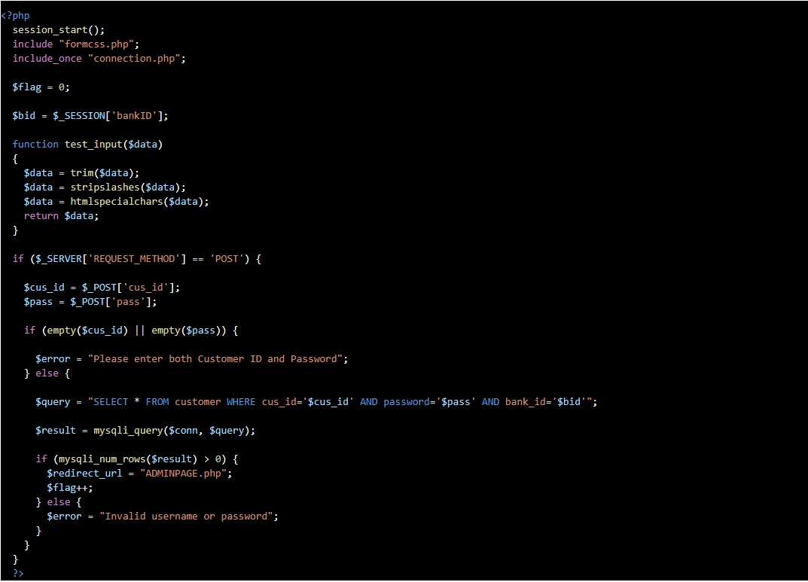

• **Register.php**

